**file:///C:/Users/Marc/Downloads/Negrao_2020.pdf**

**Automated Playtesting Unity Package**

<https://blogs.unity3d.com/2020/12/11/automate-your-playtesting-create-virtual-players-for-game-simulation/?utm_source=linkedin&utm_medium=social&utm_campaign=ml_global_generalpromo_2020-12-11_virtual-player-game-simulation-blog>

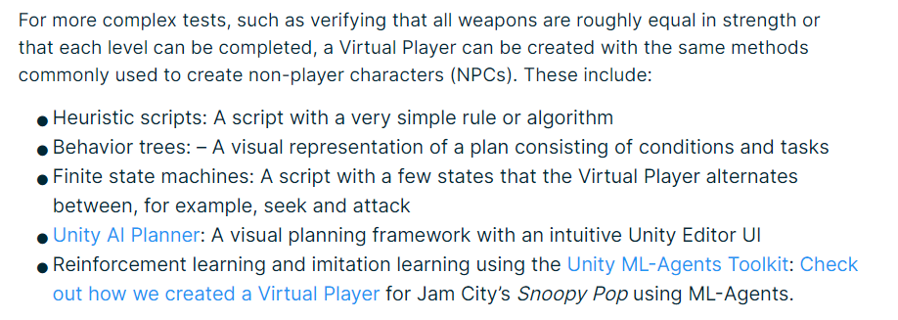

<https://www.youtube.com/watch?v=A0gpaQGu_H0>

**Run Test in parallel using Unity’s NUnit:**

<https://blog.sanderaernouts.com/running-unit-tests-in-parallel-with-nunit>

**Heatmaps in Unity:**

<https://www.youtube.com/watch?v=aWZiB7jX7C0>

**FPS level design:**

<https://citeseerx.ist.psu.edu/viewdoc/download?doi=10.1.1.486.1399&rep=rep1&type=pdf>

Many of the above patterns can be analyzed without the AI actually navigating.

There could be a first “analysis pass” where the program itself looks at the level geometry and with some algorithms, once the player has made the setup, checks for different areas, their height, their cover, etc, etc, and gives a “strength score” to said area.

<http://dl.booktolearn.com/ebooks2/computer/graphics/9781466585416_an_architectural_approach_to_level_design_2212.pdf>

(not totally related? Buy book!)

**Walkability:**

Maybe let the user click geometry faces and store each one as walkability?

Otherwise, if its complex geometry, have a grid where the user can move the points on each corner of a tile. Use snapping.

**Automated Playstesting in FPS:**

<http://antoniosliapis.com/papers/learning_the_patterns_of_balance_in_a_multi-player_shooter_game.pdf>

<http://julian.togelius.com/Cardamone2011Evolving.pdf>

<https://arxiv.org/pdf/1802.06881.pdf> (procedural personas)

**Composition:**

Another aspect that I could take into account.

<http://level-design.org/?page_id=2274>

**Multiplayer Level Design:**

<http://www.benb-design.net/Articles/benb_article02.pdf>

**Game / Level Design Metrics:**

<https://book.leveldesignbook.com/process/blockout/metrics>

**… + Rational Level Design (RLD):**

<https://www.gamasutra.com/blogs/LukeMcMillan/20130806/197147/The_Rational_Design_Handbook_An_Intro_to_RLD.php>

**Cover, Space, Height, Blockout Dimensions...**

<https://tf2maps.net/threads/guide-scale-and-your-map.12605/>

**Player Types:**

<https://www.gamasutra.com/view/feature/6474/personality_and_play_styles_a_.php?print=1>